Alex Trier, Alex Santella and Jim Moran
Health Education Lesson Plan

Descriptive Information

Skill Emphasis (NHES): N/A

Grade Level: 7th

Content Area of Health: Body Systems/Digestive System

Content Descriptor & Sub-Descriptor(s):
4. Balancing Food intake and Physical Activity
4.1 How to assess food intake to determine energy intake
4.2 How energy is expended during exercise/activity

Title of Lesson: Flowing through the Digestive System

PA Standard (Health & PE):
10.1.3. B - Identify and know the location and function of the major body organs and systems
- Circulatory
- Respiratory
- Muscular
- Skeletal
- Digestive

Curricular Connections: Public Speaking, Communication skills/Biology

Adolescent Risk Behavior (if applicable): N/A

Behavioral Objective(s)
Cognitive: After the lesson students will be able to recall the different parts of the digestive system and their functions

Affective: During the class discussion students will contribute their ideas on the benefits a digestive system has on the body

Brief Outline of Today’s Lesson
1.Introduction
2. Bell Ringer: Racing down the Digestive System.
3.Content - PowerPoint
4.In-class Learning Activity – Brochure with partners
5.In-class Activity Assessment
6.Final Thoughts/Conclusion of Digestive system lesson
7.Classroom Management

Expanded Outline of Today’s Lesson
1.Introduction to the Lesson (Set Induction):
Who has ever wondered the pathway the food takes when going through the body? Does anyone know where the digestive system starts and how it ends (appropriate answers only)? (Answer: Mouth – Anus) Did you know there are 12 main components of the digestive system? Who thinks they can name some part of them? What are they? Good, well the digestive system is a very important function of out body and turns the food we eat into energy so we can function daily. The digestive system gets rid of the waste the body doesn’t need and keeps what we do need!

2.Bell Ringer (Instant Activity): Racing down the Digestive System
Students will be split up into groups of 6. Each student will be given 2 parts of the digestive system that add up to create the whole system. As a group, they are to get in order from start to finish of the digestive system. Once in the proper order they are to send a ball (piece of food) down the digestive system. As the ball is going thru each part the student must call out the name of their part of the digestive system. Make sure your order is correct or the food will not be able to pass through the system. Did anyone’s food not make it through the whole digestive system? What part of the digestive system breaks down the food?

3.Content & Instructional Strategies:
I. What is the Digestive System? (Lecture, Q & A)
- Is a group of organs working together to convert food to energy and basic nutrients to feed your body. Food that passes through in the digestive system in a long tube inside the body is known as the gastrointestinal tract (GI tract). GI tract consists of oral cavity, pharynx, esophagus, stomach, small intestines, and large intestines.
- Organs included of the Digestive System are teeth, tongue, salivary glands, liver, gallbladder, and pancreas.
II. 6 Major Functions of the Digestive System. (Lecture, Q & A)
- 1. Ingestion- first function of the digestive system and is the intake of food. The mouth is important for this function. The mouth and stomach are key components to store food and waits to be digested.
- 2. Secretion of fluids and digestive enzymes- in an entire day the digestive system secretes about 7 liters of fluids. Some fluids include saliva, mucus, enzymes, and bile.
- 3. Mixing & Movement of food and wastes through body: 3 main processes to move and mix food: A. Swallowing- process of using skeletal muscles in the mouth and tongue to push food out of the mouth through the pharynx, and into the esophagus. B. Peristalsis- is a muscular wave that travels through the GI tract, moving digested food down the GI tract. C. Segmentation- helps increase absorption of nutrients by mixing food
- 4. Digestion- process of turning big pieces of food into little pieces. Begins with chewing of food by the teeth and continues through mixing of food by the stomach. Bile an important component produced by liver is used to break fats into smaller pieces.
- 5. Absorption of nutrients- begins in the stomach with simple molecules like water being absorbed directly into the bloodstream. Most absorption takes place in the SI.
- 6. Excretion- final function of the digestive system is the excretion of waste in a process known as defecation. Defecation removes indigestible substances from the body.
III. Process of Digestive System. (Lecture, Q & A)
- *Mouth- digestive tract begins and enzymes are released into the mouth to start the process of digestion.
- Pharynx- food and air move through it, its part of the respiratory and digestive system.
- Epiglottis- small piece of tissue that covers the opening of larynx(air passage to lungs) to keep food and liquid out of the lungs when you swallow
- *Esophagus- muscular tube that moves food from pharynx to the stomach.
- Liver- body’s largest internal organ. Liver can store energy and help body get rid of toxins.
- *Gallbladder- small pouch that stores bile. It releases bile into the duodenum to help digest fats in the food you eat.
- *Stomach- can hold acidic food needed to break down the food.
- Pancreas- creates hormone insulin to regulate blood glucose level. It also makes enzymes to break down food in the intestines.
- *Small Intestine- It lasts longer than the large intestine and absorbs nutrients. Incudes three section the duodenum, jejunum, and ileum.
- *Large Intestine- includes cecum, colon, and rectum. Water is removed and feces are formed
- Appendix- attaches to the cecum, when it gets inflamed it is called the appendicitis.
- *Anus- is the exit point of the digestive tract where feces leave the body.
IV. Things That Can Go Wrong
- Everyone has at least a digestive problem. Conditions that can occur are indigestion and diarrhea that are common. To get better from this is simply time or can get treatment.
A. Conditions Affect the Stomach and Intestines:
- Celiac disease- a disorder caused by protein gluten. People with celiac disease have trouble digesting the nutrients from their food because foods with gluten damage the intestines.
- Diarrhea- moves the intestines quickly and there isn’t enough time for water to be absorbed before the feces are pushed out. Constipation- is the opposite, do not move fast and waste stay in the LI so long that water is removed and feces becomes hard.
- Irritable bowel syndrome (IBS)- common intestinal disorder affects the colon. When the colon isnt working properly, a person may feel cramps, bloating, and diarrhea are signs of IBS. Treatment for this is by making dietary and lifestyle changes, as well as medications.

4. In-Class Learning Activity(ies): “Traveling the Digestive System”
- Students will work in groups of 2 for this activity.
- Each group will be creating a brochure that will serve as a “travel guide” of the digestive tract.
- This travel brochure should be designed as if the digestive system was a vacation get away.
- Encourage all students to share ideas and provide input for the brochure design!
- The brochure must include:
  - A brief description for all seven “locations” in the digestive tract.
  - The function/functions (recreational activities) for all seven “locations” in the digestive tract.
  - Description of the structure (historic landmarks) for all seven “locations” in the digestive tract.
  - Attractiveness (eye catching, colorful, organized)
  - Cover page (Title, color, and drawing included)
  - Creativity and uniqueness
  - Seven “locations” of the digestive system include:
    - Mouth
    - Esophagus
    - Gall Bladder
    - Stomach
    - Small Intestine
    - Large Intestine
    - Anus

5. In-Class Learning Activity Assessment-Description & Criteria
  - An analytical rubric will be used to grade the in-class learning activity, “Traveling the Digestive System” on content (Core Concepts), health skills and other specific criteria.
  - Students will create a brochure that would be used as a guide for traveling the digestive system and it must be accurate, comprehensive, show relationships between concepts, and draw conclusions. The CC criteria on the analytical rubric below will be used to assess the content portion of the activity.

Additional criteria are characteristics of the activity that are not content or skill-related. These criteria include: a brief description, a drawing, the structure, and function for all seven “locations” of the digestive tract, brochure attractiveness (color, eye catching, organized), a cover page (title and drawing), and creativity/uniqueness.

  - “Travel the Digestive System” brochures will be graded using an analytical rubric based on core concepts and additional criteria.
  - Core Concepts
    - Content for the Poster Creation Activity shows:
      - Accuracy
      - Comprehensiveness
      - Relationships among concepts
      - Conclusions drawn

- Additional Criteria:
  - Description, drawing, function, and structure for all seven “locations” of the digestive system.
  - Cover Page (title and drawing included)
  - Attractiveness
  - Creativity and Uniqueness

5. In-Class Learning Activity Assessment-Description & Criteria
  - Include Analytical Rubric

6. Final Thoughts/Conclusion to the Lesson
The digestive system is a very important system for our body. It not only processes the food that we eat but turns it into energy and eliminates the waste we do not need. What are some ways we can maintain our digestive system? What is the main function of the digestive system? What are some conditions that affect the digestive system? Remember it’s important we take care of our digestive system and our body’s!

7. Classroom Management & Materials

- Classroom Materials
  - Handouts/Worksheets: Pictures of the parts of digestive system, “Traveling the Digestive System” student handout, digestive system diagram

  - Other Materials: Paper, colored pencils, markers

    - Classroom Management
      - For Content Delivery: Students will be in seats facing the board (Tradition style)
      - For In-Class Learning Activity: Students will work in small groups of 2

Content References

Durani, Y. (2012, October 1). Digestive System. KidsHealth - the Web's most visited site about
children's health. Retrieved , from
http://kidshealth.org/teen/your_body/body_basics/digestive_system.html#

Taylor, T. (2013, January 1). Inner Body (Digestive System) . InnerBody. Retrieved , from http://www.innerbody.com/anatomy/digestive-male

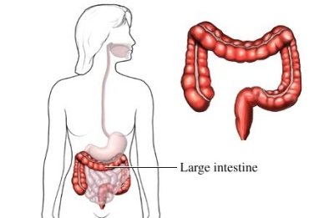
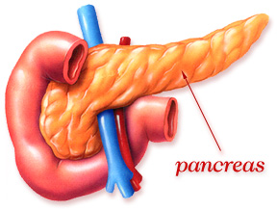
Activity Reference(s)

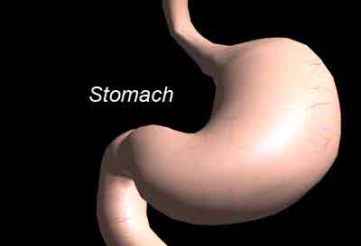

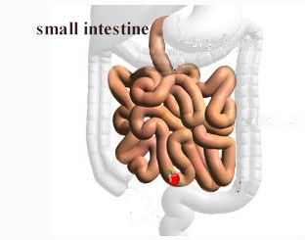

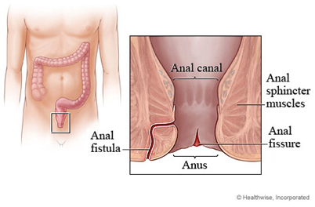

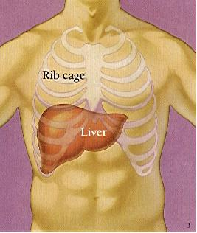

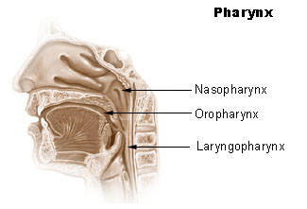

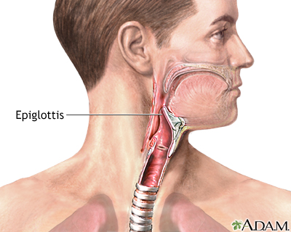

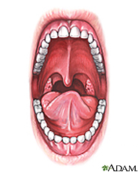

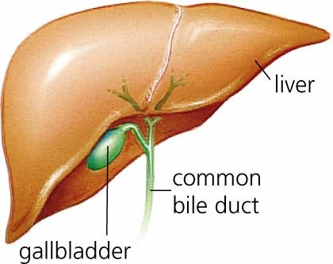

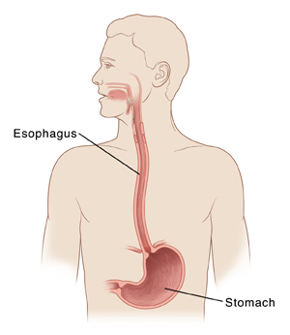
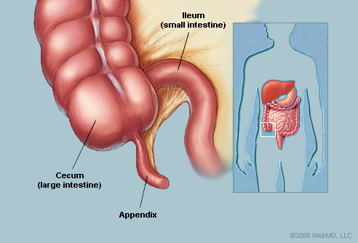

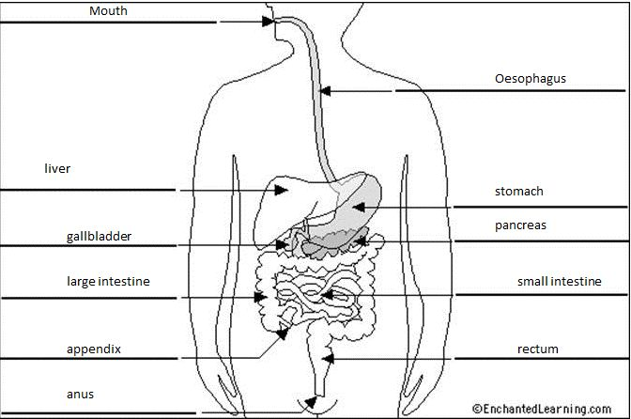
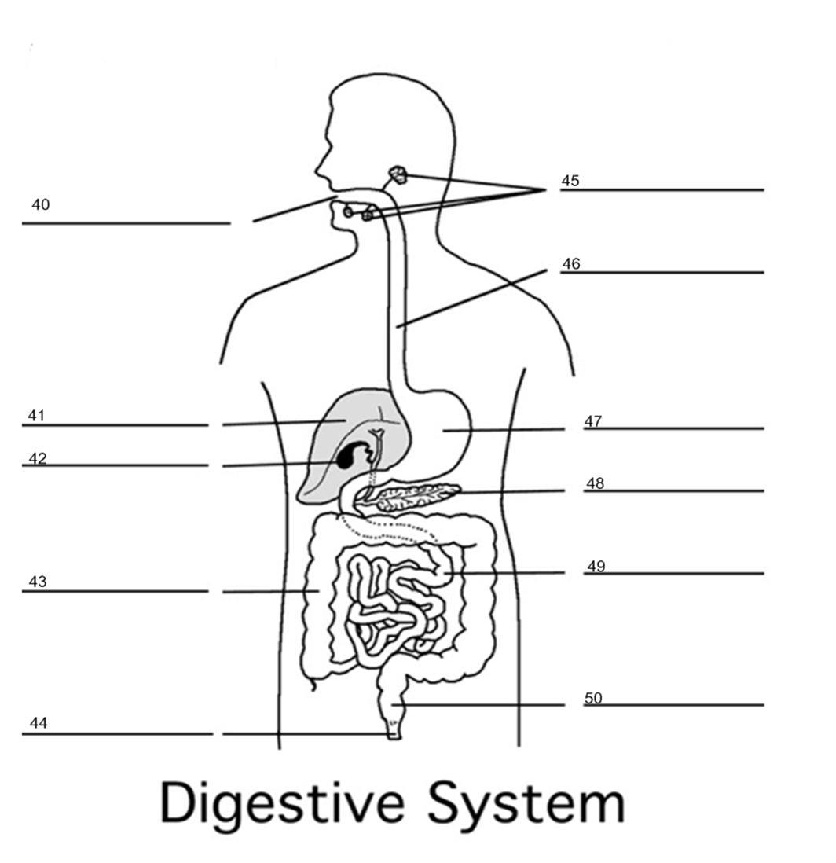

Traveling the Digestive System Activity Handout

- Students will work individually or in groups of 2 for this activity.
- You/your group will be creating a brochure that will serve as a “travel guide” of the digestive tract.
- This travel brochure should be designed as if the digestive system was a vacation get away!
- All group members should be involved in the brochure development process!
- Your group’s brochure must include:
  - A brief description for all seven “locations” in the digestive tract.
  - The function/functions (recreational activities) for all seven “locations” in the digestive tract.
  - Description of the structure (historic landmarks) for all seven “locations” in the digestive tract.
  - Attractiveness (eye catching, colorful, organized)
  - Cover page (Title and drawing included)
  - Creativity and uniqueness
  - Seven “locations” of the digestive system include:
    - Mouth
    - Esophagus
    - Gall Bladder
    - Stomach
    - Small Intestine
    - Large Intestine
    - Anus

- You will have the remainder of class to complete your brochure. Good luck, have fun, and be creative!!!

  - “Travel the Digestive System” brochures will be graded using an analytical rubric based on core concepts and additional criteria.
  - Core Concepts
    - Content for the Poster Creation Activity shows:
      - Accuracy
      - Comprehensiveness
      - Relationships among concepts
      - Conclusions drawn

- Additional Criteria:
  - Description, drawing, function, and structure for all seven “locations” of the digestive system.
  - Cover Page (title and drawing included)
  - Attractiveness
  - Creativity and Uniqueness

“Traveling the Digestive System”

Grading Assessment Form

____/4 points Content (Core Concepts)

____/4 points Description, Drawing, Function, and Structure for 7 “locations”

____/4 points Attractiveness

____/4 points Creativity & Uniqueness

____/4 points Cover Page

____/20 points Total Points

